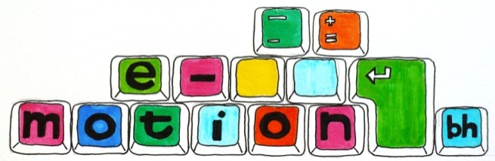

Online counselling for young people aged 13-25

**COUNSELLING AGREEMENT**

Welcome to E-motion Brighton & Hove. This agreement sets out how we can best work together online, so please feel free to let us know if anything is unclear or you’d like to know more. ☺

**About me**

My name is …………..……and I am a qualified counsellor working under the

British Association of Counsellors and Psychotherapists Codes and Ethical

Guidelines. I offer you a safe, private space to talk about whatever

you wish - nothing is too big or small. I will listen to what you have to say

without judging you or giving advice, and together we can work towards

making any changes you wish to make.

**How does online counselling work?**

Online counselling works by exchanging emails. You are free to send me any number of emails as you wish during the week, and I will respond to them in one reply. You will need to send me your email by…………… and I will respond on…………

We can have up to 12 weeks in total to work together and as we go along I will check in with you to make sure you are getting what you need from your counselling.

After you have ended counselling with your counsellor you will always be welcome to apply for more sessions by contacting [frankie@e-motionbh.org.uk](mailto:frankie@e-motionbh.org.uk)

**Breaks in counselling**

I will let you know in advance of any holidays or breaks that I will be taking and it would be helpful if you could let me know if you need to cancel writing emails for any reason (for example if you are on holiday).

If I don’t hear from you in a week I will send an enquiry email to check if you’re ok and the technology is working.

If I don’t hear from you in two weeksI will assume that you no longer wish to have counselling, and I will send you an email to let you know that our agreement for counselling has ended. However, you will always be welcome to apply for counselling again at any time.

**Technology breakdowns**

Sometimes technology can breakdown or there may be problems with the internet so this is why we ask for your mobile number so that we can support you by text if this happens.. If you can’t get hold of me by email please call ……………….. and leave a message, stating clearly your counsellor’s name, and I will then contact you on your mobile.

**Tell us what you think**

We are always interested in how you feel and think about the

e-counselling you have received, particularly as it can help us to improve our service. For this reason Frankie will send you an online Post-Counselling Feedback form to complete after your counselling has ended.

If you have any complaints about the service you will need to email our Manager [ben.glazebrook@impact-initiatives.org.uk](mailto:ben.glazebrook@impact-initiatives.org.uk)

**Let us know you agree with the terms & conditions**

Please tick the box below to let us know that you agree with and have read the terms & conditions set out above. If you aren’t happy with anything, you are welcome to contact us to discuss any concerns or questions you might have.

□ I agree to the terms & conditions